Tenda MW5-How to add devices into blacklist
This article will guide you how to remove a device from blacklist and the steps as below.

Step1: Open Tenda WiFi APP and tap “Connected Devices”.
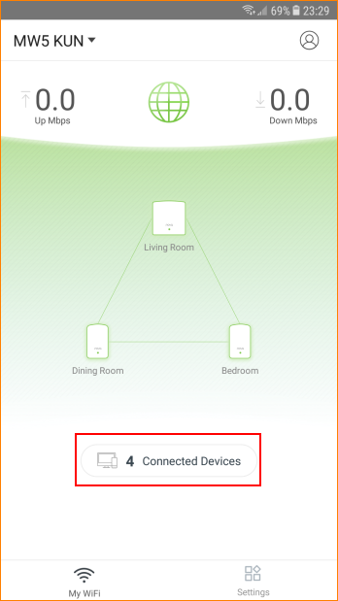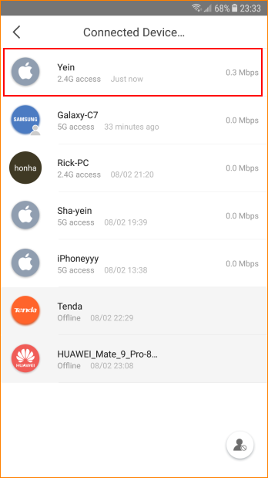

Step2: Select device which you want to block and tap “Add to Blacklist”.

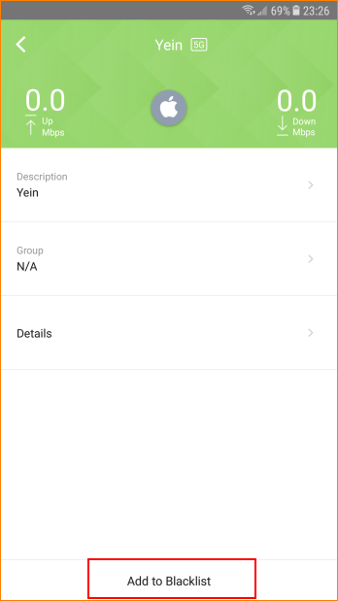

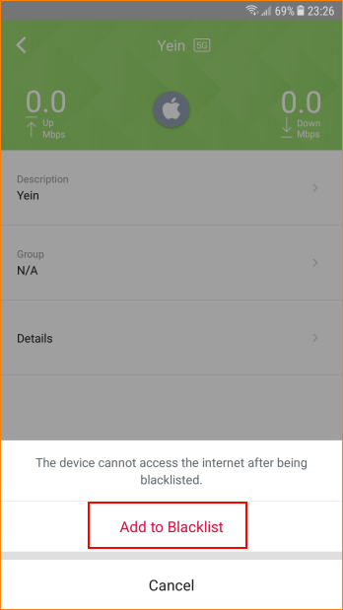

Step3: Tap gray head icon in the lower right corner and tap “Remove All Devices”.

